FIELD ARTILLERY COURSE
ARTILLERY OFFICERS

MAINTENANCE SUPERVISION OF THE M198 HOWITZER

SUBCOURSE FA3150

US Army Field Artillery School
Fort Sill, Oklahoma

EDITION 8
3 CREDIT HOURS
NEW: 1988

This subcourse is designed to teach the knowledge necessary for performing tasks
related to maintenance supervision of the M198 howitzer. This subcourse is
presented in two lessons, each lesson corresponding to a terminal objective.

LESSON 1: The M198 Howitzer

TASK NO: None.

TASK: Monitor purging and charging of the fire control equipment, monitor disassembly/assembly of the breech and the firing mechanism, verify services on the brake assemblies, verify services on the recoil mechanism, verify maintenance on the breech mechanism and the counterbalance, verify services on the equilibrator cylinders, and verify adjustments on the M17 and M18 fire control quadrant.

CONDITIONS: You will be given an M198 howitzer in a maintenance location with section tools and equipment, section personnel, TM 9-1025-211-10, TM 9-1025-211-20&P, TM 750-116, DA Pam 738-750, and a blank DA Form 2404 (Equipment Inspection and Maintenance Worksheet).

STANDARDS: Identify selected components on the M198 IAW TM 9-1025-211-10, TM 9-1025-211-20&P, and TM 750-116.

NOTE: You the student must remember that you will not always be a platoon leader. You can or may be placed in a position as a maintenance supervisor.

LESSON 2: Maintenance Services

TASK NO: 01-2660.01-0011

TASK: Monitor purging and charging of the fire control equipment.

CONDITIONS: Given an M198 howitzer, with fire control equipment on it, a nitrogen tank with hoses, gauges, goggles, tools, TM 9-1025-211-20&P, and TM 750-116, you will monitor the purging and charging of the fire control equipment.

STANDARDS: You will monitor purging and charging of the fire control equipment, and ensure that safety is used at all times IAW the referenced publications.

TASK NO: 01-2710.01-0004

TASK: Monitor disassembly/assembly of the breech and the firing mechanism.

CONDITIONS: Given an M198 howitzer with firing mechanism, M18 wrench, and TM 9-1025-211-10, monitor the disassembly/assembly of the breech and firing mechanism.

STANDARDS: You will monitor the disassembly/assembly of the breech and firing mechanism. During this task, you will ensure that safety is used. This task will be done IAW the referenced publication.

TASK NO: 01-2710.01-0005

TASK: Verify services on the brake assemblies.

CONDITIONS: Given an M198 howitzer, a mechanic with artillery mechanics tool set, cleaning materials, lubricants, required repair parts, a driver, TM 9-1025-211-10, and TM 9-1025-211-20&P, verify that services have been performed on the brake assemblies.

STANDARDS: You will verify services on the brake assemblies and ensure that safety is used. This task must be performed IAW the referenced publications.

TASK NO: 01-2710.01-0006

TASK: Verify services on the recoil mechanism.

CONDITIONS: Given an M198 howitzer with the tube set at 0 mils and TM 9-1025-211-10, verify the recoil mechanism.

STANDARDS: You will verify the services of the recoil mechanism and ensure that safety is used. This task will be performed IAW the referenced publication.

TASK NO: 01-2710.01-0007

TASK: Verify maintenance on the breech mechanism and the counterbalance.

CONDITIONS: Given an M198 howitzer, a mechanic with artillery mechanics tool set, cleaning materials, TM 9-1025-211-10, and TM 9-1025-211-20&P, verify the maintenance on the breech mechanism andcounterbalance.

STANDARDS: You will verify the maintenance on the breech mechanism and counterbalance IAW the referenced publications.

TASK NO: 01-2710.01-0008

TASK: Verify services on the equilibrator cylinders.

CONDITIONS: Given an M198 howitzer, TM 9-1025-211-10, and TM 9-1025-211-20&P, verify the services on the equilibrator cylinder.

STANDARDS: You will verify services on the equilibrator cylinders, IAW the referenced publications.

TASK NO: 01-2710.01-0009

TASK: Verify adjustments on the M17 and M18 fire control quadrant.

CONDITIONS: Given an M198 howitzer, a gunner's quadrant, an assistant, and TM 9-1025-211-10, verify the services on the M17 and M18 fire control quadrant.

STANDARDS: You will verify adjustments on the fire control quadrants IAW the referenced publication.

TABLE OF CONTENTS

Section

TITLE PAGE

Lesson 1: The M198 Howitzer

Introduction

Description

Selected Components and Controls

Summary

Lesson 2: Maintenance Services

Introduction

Purging and Charging Fire Control Equipment

Disassembling or Assembling Breech and Firing Mechanism

Monitoring Brake Assembly

Verifying Recoil Mechanism

Monitoring Breech Mechanism and Counterbalance

Monitoring and/or Adjusting Equilibrator Cylinder

Verifying Adjustments on M17 and M18 Fire Control Quadrants

Summary

EXAMINATION

Lesson 1
THE M198 HOWITZER

OBJECTIVE

Upon completion of this lesson, you will be able to identify the various parts,
controls, and equipment used to perform certain maintenance tasks on the M198
howitzer.

REFERENCES

This lesson is based on TM 9-1025-211-10, TM 750-116, and TM 9-1025-211-20&P with changes, and other materials approved for US Army field artillery instruction; however, development and progress render the text continually subject to change. Therefore, base your examination answers on material presented in this text rather than on individual or unit experience.

1. INTRODUCTION. You the student must remember that throughout your career you will be placed in a variety of duty positions, one being the maintenance
supervisor. Periodically you will find that you need to monitor or verify some
of the critical maintenance procedures performed on the M198 howitzer. This
subcourse deals with the M198 155-mm towed howitzer and various supervisor
maintenance responsibilities.

2. DESCRIPTION. The M198 155-mm howitzer (Figure 1) is an extended-range,
split-trail weapon that can be towed by a vehicle or airlifted by a helicopter.
The tube can be rotated 3,200 mils to decrease overall length for shipment or
storage. (See Table 1 for more data on the M198 howitzer.)

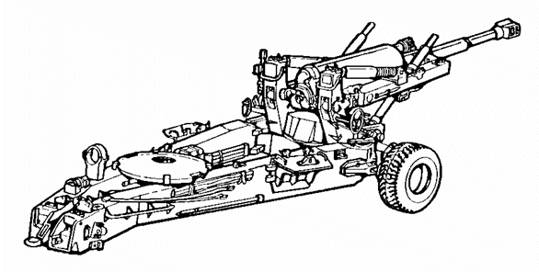

Figure 1. Howitzer, medium towed M198

Table 1. Data on 155-mm M198 howitzer.

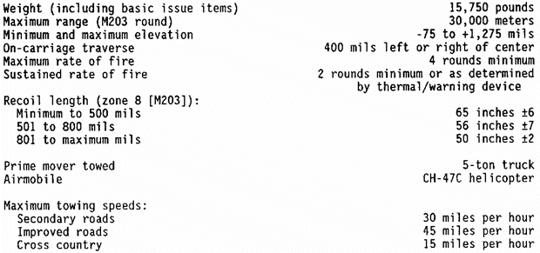

3. SELECTED COMPONENTS AND CONTROLS. To locate certain maintenance inspection
points, you need to become familiar with the names and locations of the major
components and controls of the M198 howitzer. By studying the following
paragraphs you will become familiar with these areas.

a. Setup of purging and charging equipment. The following paragraphs
describe general procedures for the setup of purging and charging equipment
and time cycles.

(1) Setup for single-stage fixture.

(a) Obtain a tank (Figure 2- A ) of dry nitrogen, and remove
the threaded protective cover B from the outlet of the tank.
Open the tank valve C momentarily to rid the valve seat of
any foreign matter.

WARNING

DO NOT DROP TANK OF COMPRESSED NITROGEN GAS. WHEN USING IN CONFINED AREAS, USE
EXTREME CARE; GAS COULD CAUSE ASPHYXIATION.

(b) Securely attach regulator D to tank valve C by using
appropriate adapter supplied with purging kit if necessary.

NOTE: Two regulator assemblies are presently in use for purging and charging
fire control materiel. The insert in Figure 2 shows regulator 5580922 E
and adapter 7680682 F while the tank is shown with regulator 11729749.

(c) Securely attach hose assembly G to the adapter H .

NOTE: When using regulator model number 11729749, adapter 10917072-2 is required to connect hose assembly to low-pressure port of regulator.

(d) Rotate pressure regulator valve I counterclockwise to the
extreme closed position.

(e) Open the nitrogen tank valve C slowly until the maximum
tank pressure is registered on the high-pressure gage J .

NOTE: If pressure indicated is less than 100 pounds per square inch (psi),
obtain and use replacement tank.

(f) Slowly rotate pressure regulator valve I clockwise until
approximately 5 psi is registered on low-pressure gage K . Check for and
eliminate any interference. Close pressure regulator valve I .

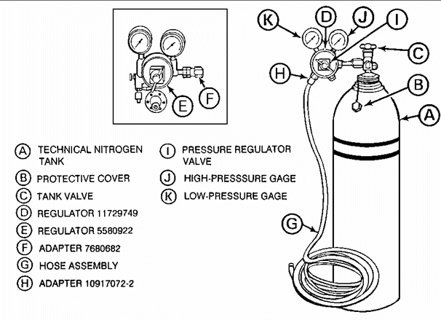

Figure 2. Setup of single-stage fixture

(2) Setup for two-stage fixture.

(a) Place a tank of dry nitrogen (Figure 3 A ) in a vertical
position in the back of the fixture so that the tank is lodged in the structural
steel "V" formation of the fixture. Secure the tank with the strap and clamping
screw arrangement provided.

(b) Secure regulator assembly B to the tank. Make certain
pressure regulator valve C is turned counterclockwise to off. Open nitrogen
tank valve D until maximum tank pressure is indicated on the high-pressure
gage E .

NOTE: If pressure indicated is less than 100 psi, obtain and use a replacement
tank.

(c) Connect hose assembly F to regulator assembly B . Open
manifold valve G .

CAUTION

AT NO TIME SHOULD THE PRESSURE BE PERMITTED TO EXCEED 15 PSI. PRESSURE GREATER
THAN 15 PSI COUID DAMAGE THE UNIT.

(d) Open transfer valve H by pulling it to the outermost
position.

(e) Close test fixture valve(s) I and ensure low-pressure gage J indicates 0 psi.

(f) Open pressure regulator valve C until low-pressure gage J
indicates 15 psi.

(g) Open test fixture valve(s) I until test fixture gage(s) K
indicate(s) proper pressure.

(h) Close manifold valve(s) G , and check pressure reading on
test fixture gage(s) K .

(i) Remove stopper(s) L from outlet pipe(s) M . Open
manifold valve(s) G , and check the pressure on test fixture gage(s) K .
Adjust fixture valve(s) K if necessary.

(j) Close manifold valve(s) G , and attach feeder tube(s) to
outlet pipe(s) M .

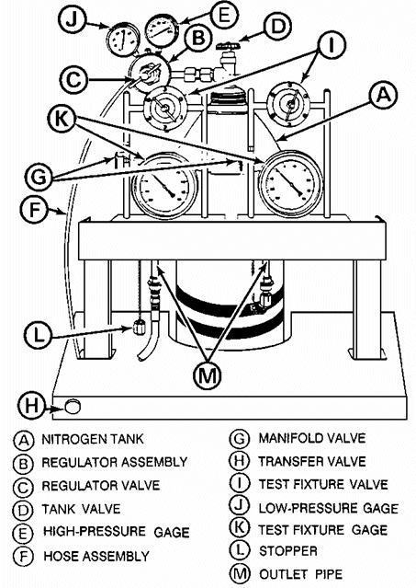

Figure 3. Two-stage purging and charging fixture.

(3) Time cycles.

(a) Maintenance personnel will purge and charge fire control
materiel every 90 days or when condensation is evident in the instrument.

(b) Maintenance personnel will purge and charge fire control
materiel being repaired whenever the repair function affects internal sealing.

NOTE: For maintenance of materiel in storage, refer to TM 740-90-1
(Administrative Storage of Equipment). For time cycles, refer to SB 740-
94-700 (Storage Serviceability Standards for ARRCOM Materiel: Fire
Control Items).

b. Breech and firing mechanism (Figure 4).

(1) Firing mechanism assembly. This mechanism provides the necessary
force which detonates the primer. The primer, in turn, ignites the powder
charges inside the chamber.

(2) Breechblock assembly. The breechblock assembly is a heavy steel
block made to withstand the explosive forces. It is securely threaded to the
breech ring assembly during firing.

(3) Obturator spindle assembly. The force of explosion (expanding
gases) exerts forces against the obturator spindle assembly, which expands the
split rings and obturator pad (gas check pad). The split rings and obturator pad provide a gas-tight seal at the breech end of the gun tube.

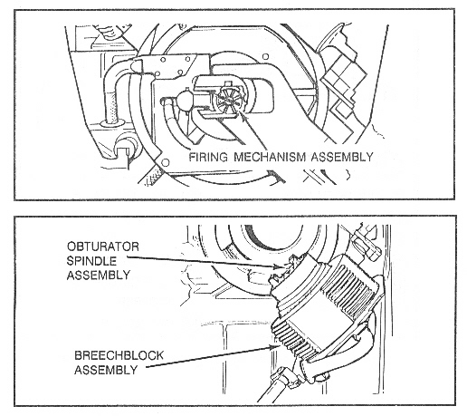

Figure 4. Breech and firing mechanism.

c. Brake assemblies (Figure 5).

(1) Wheel and axle. The wheel and axle are retractable and consist of
a pair of wheels, hand brakes, and supports mounted on the bottom carriage
assembly. Two wheel lock handles are for locking the wheel in its travel and
firing positions.

(2) Air brake system. The air brake system is an air-over-oil-type
service brake. The pressure for the system is supplied by the prime mover
through service or emergency hose assemblies. The power booster assembly
converts air pressure to oil pressure. A caliper disk hand brake is provided at
each wheel along with power-operated caliper brake head assemblies. Both braking systems are supported on each road arm.

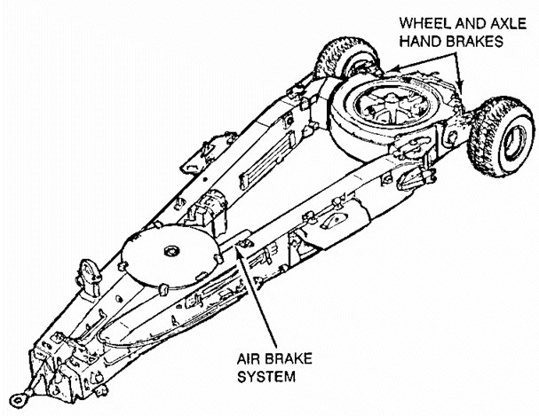

Figure 5. Brake assemblies.

d. Recoil mechanism (Figure 6).

(1) Description. The M45 recoil mechanism is a hydropneumatic,
variable, dependent-type system with a floating piston. The principal assemblies
of this mechanism are:

- One replenisher cylinder assembly.

- One sleeve bearing assembly.

- Two recoil cylinder assemblies.

- One recuperator cylinder assembly.

- One air cylinder assembly.

- One oil valve assembly.

- Three yokes.

- Two rails.

(2) Function.

(a) During recoil, hydraulic fluid is forced from the two recoil
cylinder assemblies through the front (oil transfer) yoke and control orifice of
the regulator assembly. As the control rod and floating piston are displaced by
the increased volume of hydraulic fluid in the recuperator cylinder assembly, the fluid throttling orifice area is varied, and the nitrogen pressure is compressed on the floating piston. Nitrogen flows from the gas side of the recuperator cylinder assembly, through the air cylinder assembly, and to the replenisher cylinder assembly.

(b) During counterrecoil, the gas expands pulsing against the
floating piston. This forces fluid out of the recuperator cylinder assembly
through the yoke into the recoil cylinder assemblies, returning the recoiling
parts back to battery. A check valve in the regulator assembly is closed during
counterrecoil, and the fluid flow rate is controlled by the counterrecoil grooves in the regulator assembly. Check oil reserve indicator for proper oil reserve (2 through 10 reserves).

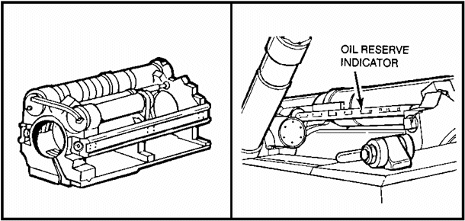

Figure 6. Recoil mechanism.

e. Breech mechanism and counterbalance (Figure 7). The breech mechanism
assembly seals the rear of the gun tube, directing the force of explosion
(expanding gases) against the rear of the projectile. This provides the maximum
force to propel the projectile in flight. The breech mechanism assembly is
manually operated, and the ammunition is manually loaded. The breech mechanism
includes the firing mechanism assembly, breechblock assembly, and the obturator
spindle assembly. The counterbalance serves the same principle as the
equilibrator cylinders. The counterbalance helps to equalize the weight of the
breechblock. Without the counterbalance, a person trying to open the breechblock would be moving a part that actually weighs 128 pounds. With the counterbalance, a person opening the breechblock would be moving a part that weighs about 20 to 25 pounds.

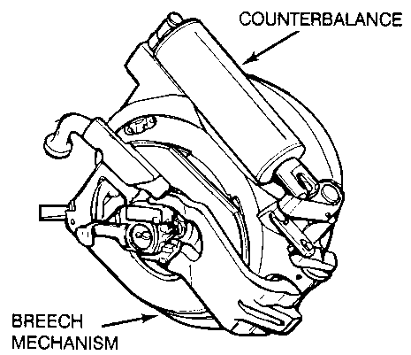

Figure 7. Breech mechanism and counterbalance.

f. Equilibrator cylinders (Figure 8). These two pneumatic-type (puller-
type) cylinders balance the weight of the tipping parts and reduce the manual
effort required to elevate the weapon.

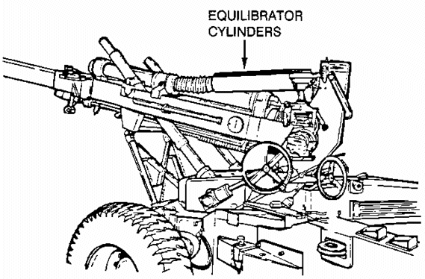

Figure 8. Equilibrator cyclinders.

g. Fire control equipment (Figure 9). The following items are used to lay the cannon in direct or indirect fire.

(1) M17 and M18 fire control quadrants. The dual fire control
quadrants are identical except for the right- and left-hand worms, gears, and the cross level vial that is on the M18 fire control quadrant. The dual equipment permits either the assistant gunner or the gunner to lay the cannon in elevation. The counters and level vials are self-illuminated.

(2) M171 telescope and quadrant mount. A cant-compensating mount
supports the M137 panoramic telescope and M17 fire control quadrant. Self-
illuminated level vials are provided for cross and pitch leveling.

(3) M172 telescope and quadrant mount. This mount is installed on the
right trunnion of the howitzer to support the M138 elbow telescope and M18 fire
control quadrant. Two self-illuminated level vials on this quadrant provide for
cross-leveling the mount and laying the cannon in elevation. It also includes a
vertical surface for measuring weapon elevation with the M1A2 gunner's quadrant,
and it supports the M139 alignment device during boresighting.

(4) M137 panoramic telescope. This is a 4-power, 10-degree, field-of-view instrument with digital counters. The reticle and all counters are self-
illuminated.

(5) M138 elbow telescope. This is an 8-power, 8-degree, field-of-view
instrument. A self-illuminated elevation reticle is provided for direct fire. A self-illuminated cursor reticle provides for range settings on the mil scale
reticle.

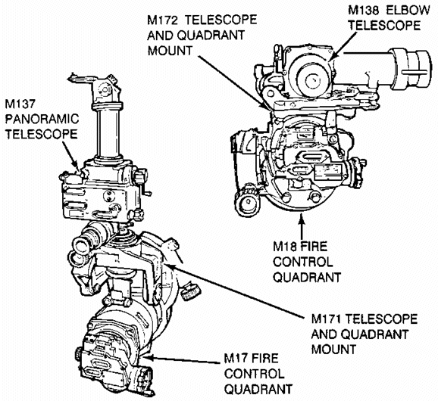

Figure 9. Fire control equipment.

PRACTICE EXERCISES:

Complete the following exercises by circling T for true or F for false, circling
the letter preceding the correct answer, or filling in the blanks as appropriate. Be sure to complete the practice exercises as they appear. They are "building blocks" and will help you complete the rest of the subcourse successfully. The answers follow the last exercise and are separated by a row of slashes (////). If any of your answers are incorrect, restudy the appropriate part of the subcourse before you continue.

1. Identify the lettered components in Figure 10.

A ______ ______ ______ D ______ ______ ______

B ______ ______ ______ ______ E ______ ______ ______ ______ ______

C ______ ______ ______ ______ F ______ ______ ______ _______

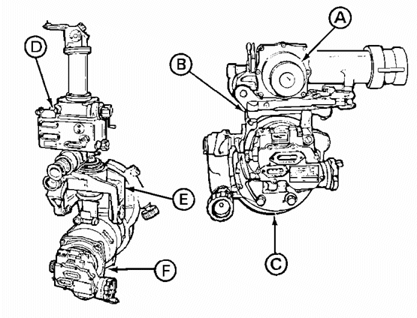

Figure 10. Components for Practice Exercise 1.

2. Identify the lettered components in Figure 11.

A ______ ______ ______ C ______ ______ ______

B ______ ______ ______ D ______ ______

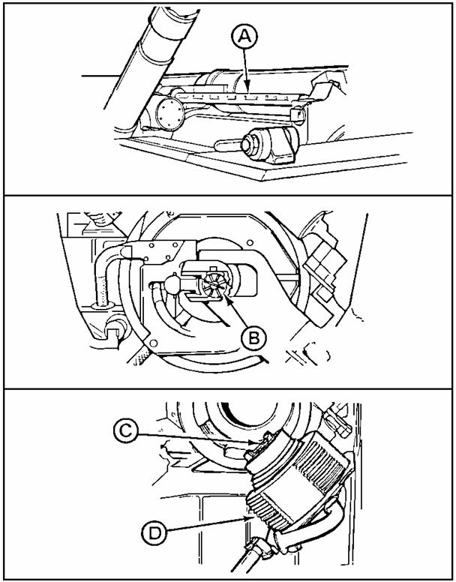

Figure 11. Components for Practice Exercise 2.

3. Identify the lettered components in Figure 12.

A _________ ________ B ___________________

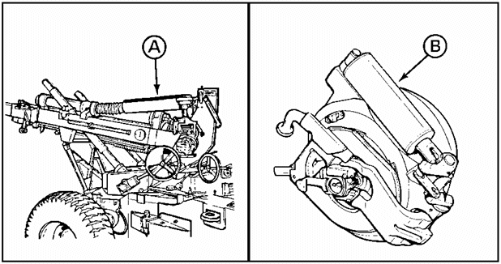

Figure 12. Components for Practice Exercise 3.

4. Identify the lettered components in Figure 13.

A _____ _____ _____ _____ _____ B ________ ________ ________

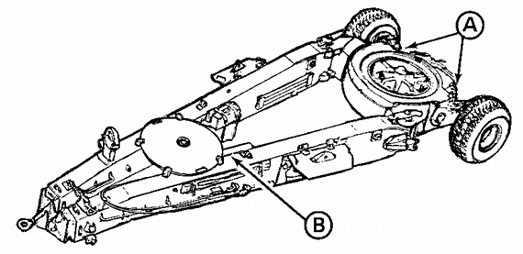

/ / / / / / / / / / / / / / / / / / / / / / / / / / / / / / / / / / / / / / /

ANSWERS:

1. A M138 elbow telescope D M137 panoramic telescope

B M172 telescope and quadrant E M171 telescope and quadrant mount

C M18 fire control quadrant F M17 fire control quadrant

2. A oil reserve indicator

B firing mechanism assembly

C obturator spindle assembly

D breechblock assembly

3. A equilibrator cylinders

B counterbalance or counterbalance assembly

4. A wheel and axle hand brakes

B air brake system

/ / / / / / / / / / / / / / / / / / / / / / / / / / / / / / / / / / / / / / /

4. SUMMARY. In this lesson, you have been shown seven of the critical
maintenance tasks that you will be required to either verify or monitor. In
Lesson 2, you will be shown the steps taken to perform these procedures.

Lesson 2
MAINTENANCE SERVICES

OBJECTIVE

Upon completion of this lesson, you will be able to monitor or verify the
following services on the M198 howitzer:

- Purge and charge the fire control equipment.

- Disassemble/assemble of the breech and firing mechanism.

- Monitoring brake assemblies.

- Verify mechanism recoil mechanism.

- Monitor breech mechanism and counterbalance.

- Monitor and/or adjust equilibrator cylinders.

- Verify adjustments on the M17 and M18 fire control quadrants.

REFERENCES

This lesson is based on TM 9-1025-211-10, TM 9-1025-211-20&P, TM 750-116 with
changes, and other materials approved for US Army field artillery instruction;
however, development and progress render the text continually subject to change.
Therefore, base your examination answers on material presented in this text
rather than on individual or unit experience.

5. INTRODUCTION. Monitoring or verifying services is an important part of the
systematic care, as is inspecting, and servicing of equipment to maintain it in
serviceable condition. The crew can monitor or verify equipment at the same time they perform their selected preventive maintenance checks and services (PMCS).

6. PURGING AND CHARGING FIRE CONTROL EQUIPMENT.

a. M17 and M18 quadrants.

WARNING

NEVER EXCEED THE PRESSURES INDICATED IN THE FOLLOWING PROCEDURE. DO NOT PURGE
ANY INSTRUMENT IF THERE IS NO ILLUMINATION IN THE COUNTER ASSEMBLY. THE
RADIOLOGICAL PROTECTION OFFICER (RPO) MUST BE NOTIFIED, AND THE INSTRUMENT WILL
BE REPLACED BY A SERVICEABLE ONE AND EVACUATED PROPERLY PACKED TO DIRECT SUPPORT.

NOTE: Purging and charging instructions for the M17 and M18 quadrants are
the same. The following figures show the M17 quadrant. The M18
quadrant, similar to the M17, is not illustrated.

(1) Remove the entrance port cap (gray) (Figure 14 A ).

(2) Attach the free end of the hose assembly B to the entrance port
valve C .

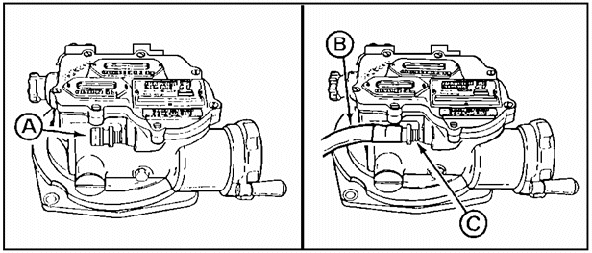

Figure 14. Entrance port cap and valve.

(3) Open the valve (Figure 15 A ) on the pressure regulator B
until 7 psi (0.49 kilogram per square centimeter [kg/cm²]) is registered
on the low-pressure gage C . Maintain this pressure for 5 minutes and then
close the valve.

(4) Observe the low-pressure gage C , and note the pressure when
the relief valve D closes. If the relief valve closed at 1 psi (0.07 kg/cm²),
proceed to paragraph (6).

(5) If the relief valve D closes at 5 psi (0.35 kg/cm²), remove the
hose assembly E and depress the valve core until all the pressure has escaped.
Reconnect the hose assembly E , and turn the valve A on the pressure
regulator clockwise until the low-pressure gage C indicates 1 psi (0.07
kg/cm²). Maintain pressure for 1 minute.

(6) Remove the hose assembly E from the entrance port valve F .

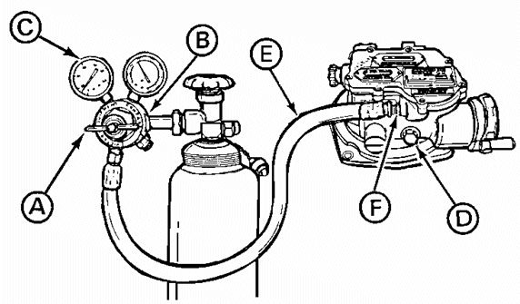

Figure 15. Pressure regulator valve and gage.

(7) Install the entrance port cap (gray) (Figure 14 A ).

b. M137 panoramic telescope.

WARNING

NEVER EXCEED THE PRESSURES IN THE FOLLOWING PROCEDURE. DO NOT PURGE IF THERE IS
NO ILLUMINATION IN THE COUNTER ASSEMBLY. THE RADIOLOGICAL PROTECTION OFFICER
MUST BE NOTIFIED, AND THE M137 TELESCOPE WILL BE REPLACED BY A SERVICEABLE ONE
AND EVACUATED PROPERLY PACKED TO DIRECT SUPPORT.

(1) Remove the entrance port cap (Figure 16 A ) from the
optic assembly B .

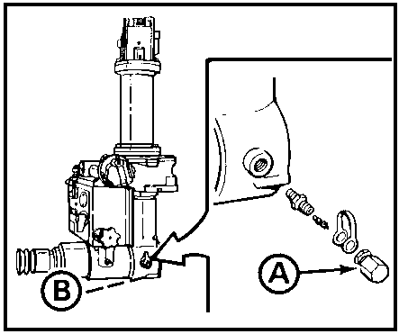

Figure 16. Entrance port cap.

(2) Attach the free end of the hose assembly (Figure 17 A ) to
the entrance port valve B .

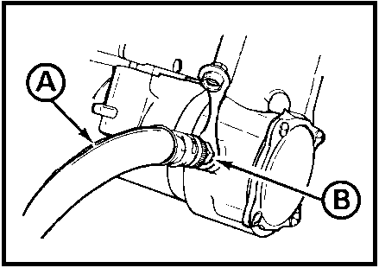

Figure 17. Hose assembly.

(3) Open the valve (Figure 18 A ) on the pressure regulator B
until 7 psi (0.49 kg/cm²) is registered on the low-pressure gage
C . Maintain this pressure 5 minutes or until all traces of moisture in the
counter box assembly have been removed. Close the valve.

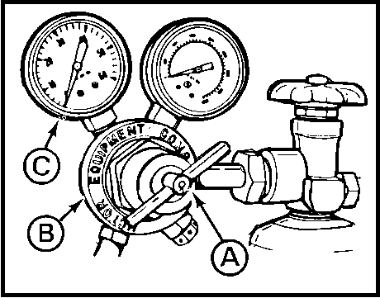

Figure 18. Pressure regulator valve and gage.

(4) Remove the hose assembly (Figure 19 A ) from the
entrance port valve B .

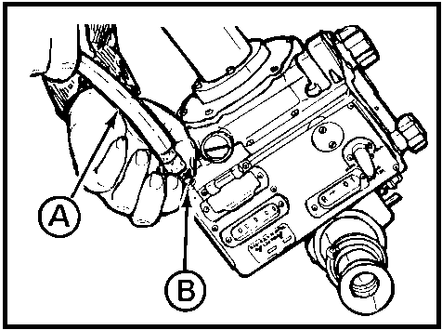

Figure 19. Entrance port valve.

(5) Install the entrance port cap (gray)(Figure 20 A ) on the
counter box assembly B .

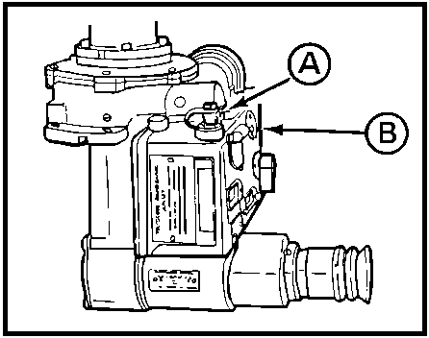

Figure 20. Counter box assembly.

c. M138 elbow telescope.

WARNING

NEVER EXCEED THE PRESSURES INDICATED IN THE FOLLOWING PROCEDURE. DO NOT PURGE
ANY INSTRUMENT IF THERE IS NO ILLUMINATION IN THE COUNTER ASSEMBLY. THE
RADIOLOGICAL PROTECTION OFFICER MUST BE NOTIFIED, AND THE INSTRUMENT WILL BE
REPLACED BY A SERVICEABLE ONE AND EVACUATED PROPERLY PACKED TO DIRECT SUPPORT.

(1) Remove the entrance port cap (Figure 21).

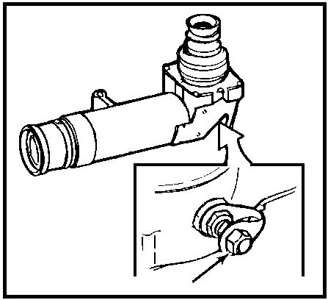

Figure 21. Entrance port cap.

(2) Attach the free end of the hose assembly (Figure 22 A ) to
the entrance port valve B .

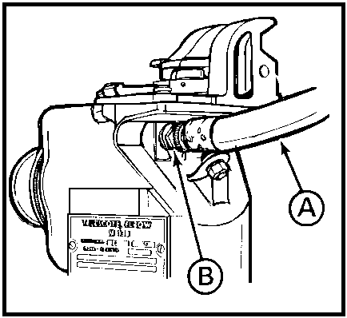

Figure 22. Entrance port valve.

(3) Open the valve (Figure 23 A ) on the pressure regulator B
until 8 psi (0.56 kg/cm²) is Registered on the low-pressure gage C . Maintain this pressure for 5 minutes.

(4) Ensure nitrogen is escaping from the relief valve D .
If purging cannot be accomplished, repair if necessary.

(5) Close the valve A on the pressure regulator. Observe the
low-pressure gage C , and ensure that the relief valve D closes at 5
psi (0.35 kg/cm²).

(6) Install the entrance port cap (Figure 21).

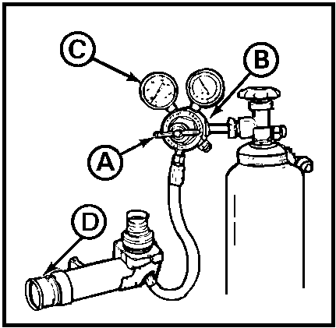

Figure 23. Pressure regulator.

7. DISASSEMBLING OR ASSEMBLING BREECH AND FIRING MECHANISM. The platoon leader must ensure that this task is performed according to the steps listed below.

a. Disassembling breech.

(1) Place the firing mechanism block assembly (Figure 24 A ) in the
left position.

(2) Press in the firing mechanism assembly B . Turn it
approximately 1/4 turn clockwise, and remove it.

(3) Rotate the breechblock lever C of the breechblock assembly D
until it is in a horizontal position.

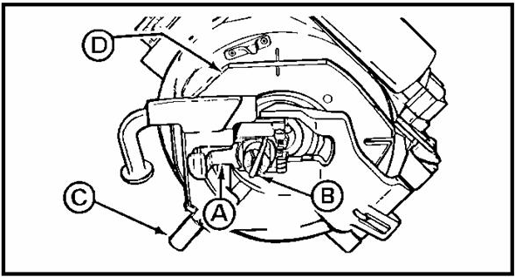

Figure 24. Firing mechanism block assembly and breechlock assembly.

(4) Squeeze spring pin (Figure 25 A ) and firing mechanism block B
together. Slide to the right, and remove.

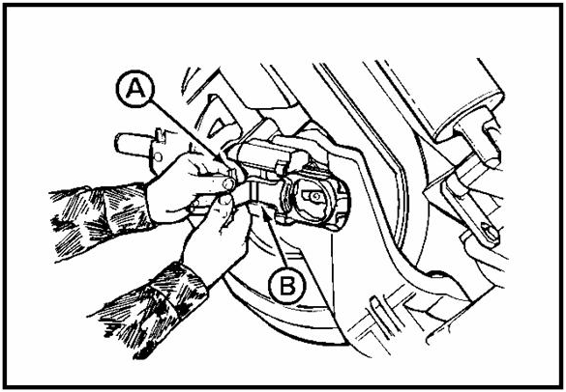

Figure 25. Spring pin and firing mechanism block.

(5) Using the handle (Figure 26 A ), open the breechblock
assembly B .

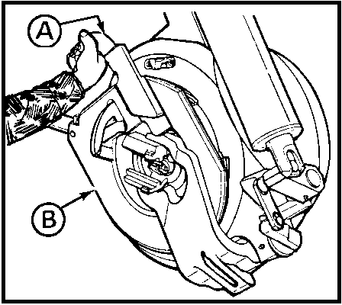

Figure 26. Breechblock assembly handle.

(6) Lift away the cartridge extractor (Figure 27 A ) from the
obturator spindle assembly B .

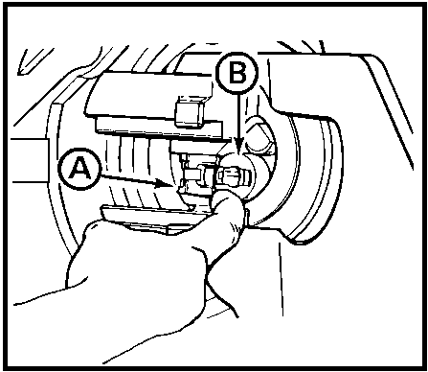

Figure 27. Cartridge extractor.

(7) Depress the plunger (Figure 28 A ) located at the end of
the obturator spindle assembly B .

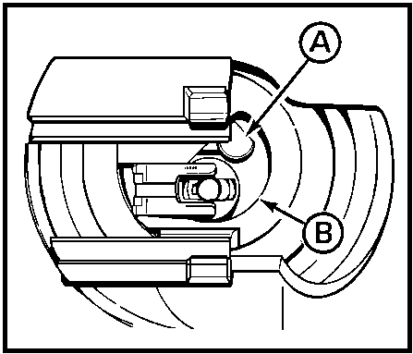

Figure 28. Plunger.

(8) While supporting the housing assembly (Figure 29 A ),
turn the obturator spindle assembly B clockwise in the opposite direction of
the arrow until the housing assembly is released.

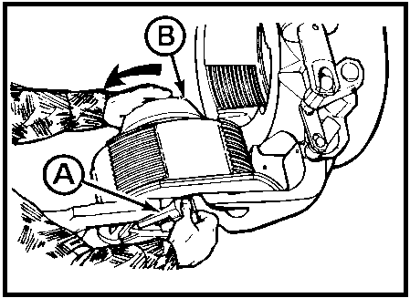

Figure 29. Obturator spindle assembly.

NOTE: If obturator spindle assembly (Figure 30 A ) cannot be turned by
hand, a 1/2-inch square drive socket handle may be inserted in square
opening B .

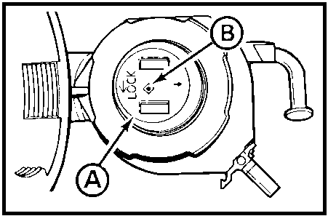

Figure 30. Square opening.

(9) Remove the housing assembly (Figure 31).

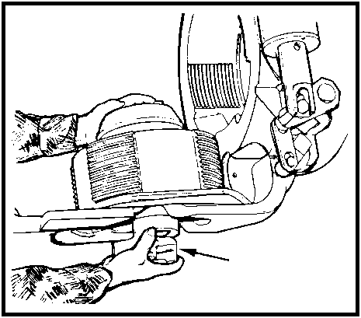

Figure 31. Removing housing assembly.

(10) Lift the obturator spindle assembly (Figure 32 A ) from
the breechblock assembly B ).

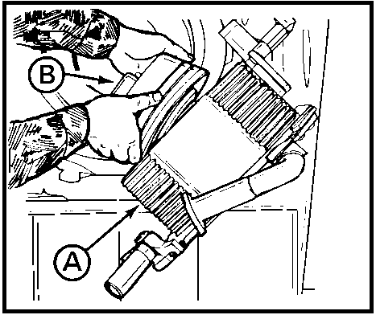

Figure 32. Lifting obturator spindle assembly.

(11) Remove the disk (Figure 33 A ), rear split ring B , inner
ring C , obturator pad D , and front split ring E .

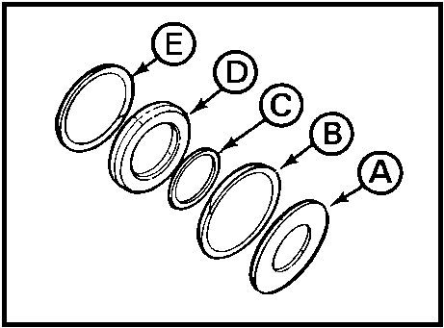

Figure 33. Disks, rings and pads from obturator spindle assembly.

WARNING

MAKE SURE PIN (FIGURE 34 A ) IS INSTALLED BEFORE REMOVING BREECHBLOCK ASSEMBLY.

(12) Install pin in hole in breech counterbalance B .

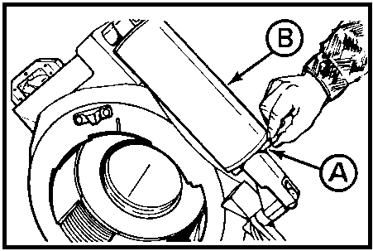

Figure 34. Pin.

WARNING

BREECHBLOCK ASSEMBLY (FIGURE 35 A ) WEIGHS 128 POUNDS (58.06 KG).

(13) Lift the breechblock assembly from the carrier B while
the other crewman holds the carrier down by grasping in the inner lip of
the carrier. Place the breechblock assembly on a solid surface.

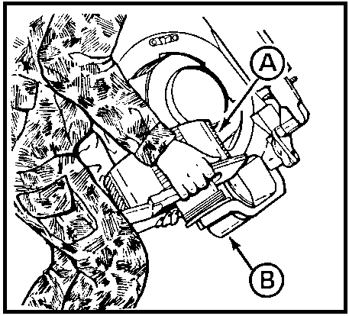

Figure 35. Lifting breechblock assembly from carrier.

(14) Clean all parts of the breechblock assembly with cleaning
compound (TM 9-1025-211-10), and wipe it dry.

(15) Inspect the breechblock assembly for damaged parts (TM 9-1025-
211-10).

b. Reassembling breech.

(1) Place the breechblock assembly (Figure 36 A ) in position on the
carrier B .

NOTE: When installing split rings, ensure splits on front split ring C and
rear split ring D are opposite (180ø apart).

(2) Install front split ring C , obturator pad E , inner ring
F , rear split ring D and disk G on obturator spindle assembly H .

(3) Install obturator spindle assembly H in hole in center of
breechblock assembly A and carrier B .

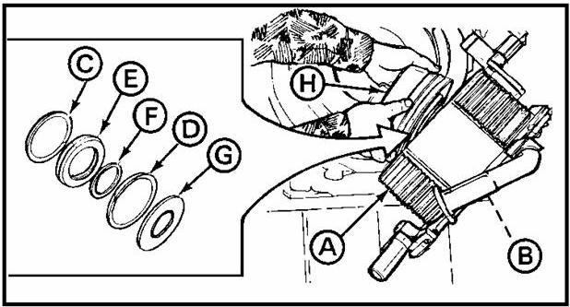

Figure 36. Installing rings, pad, and disk.

(4) Place housing assembly (Figure 37 A ) in position in carrier.

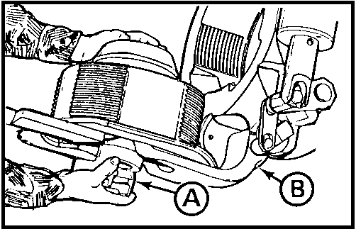

Figure 37. Placing housing assembly in carrier.

NOTE: Ensure plunger on obturator spindle assembly (Figure 38 A ) is in fully
locked position.

(5) While supporting the housing assembly B , turn the obturator spindle assembly clockwise in the direction of the arrow until it engages to a definite stop.

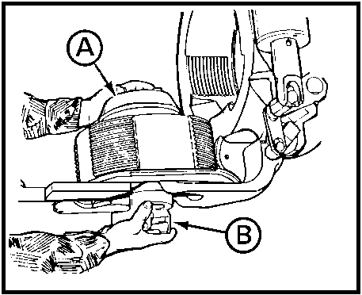

Figure 38. Ensuring plunger in locked position.

(6) Open the breechblock assembly further, and remove the pin
(Figure 39 A ) from the hole in the breech counterbalance B .

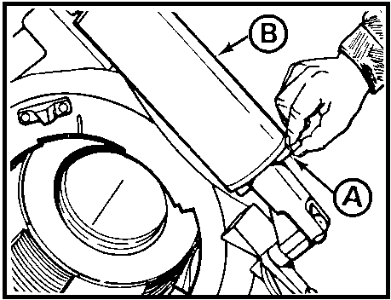

Figure 39. Removing pin from hole.

(7) Using the handle (Figure 40 A ) close the breech-
block assembly B ; but do not rotate it. (Leave slot C in
horizontal position.)

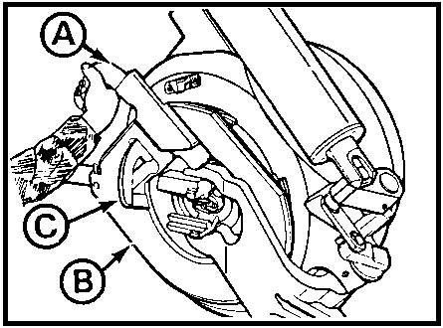

Figure 40. Closing breech-block assembly.

(8) Push the cartridge extractor (Figure 41 A ) against the
end of the obturator spindle assembly B .

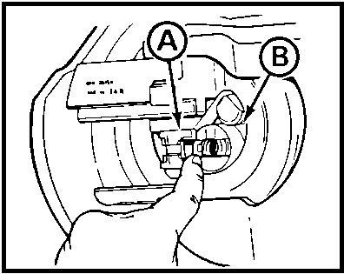

Figure 41. Pushing cartridge extractor.

(9) Install the firing mechanism block assembly (Figure 42 A ), and
slide it to the left.

(10) Install the firing mechanism assembly B by placing it in position in the firing mechanism block assembly A . Press in, and turn counterclockwise.

(11) Push the handle C down until the breech is closed and locked.

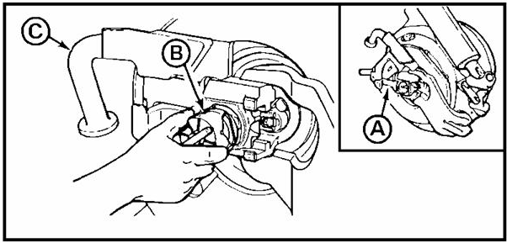

Figure 42. Installing fire mechanism assembly.

c. Disassembling firing mechanism assembly.

(1) Place the firing mechanism assembly (Figure 43 A ) on a solid
surface.

(2) Place the M18 fuze-setter wrench B over the case C and
follower D , and depress. Remove the pin E from the lanyard lever F and
hammer guide yoke G . Release the spring tension slowly.

(3) Remove the lanyard lever F and case C .

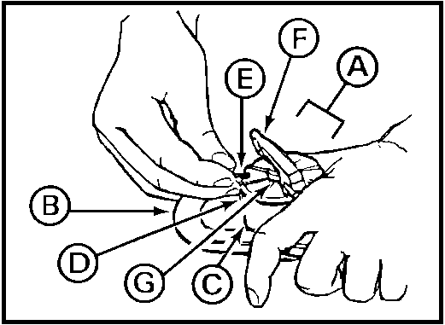

Figure 43. Removing lanyard lever and case.

(4) Remove the cup spring (Figure 44 A ) and yoke spring B .

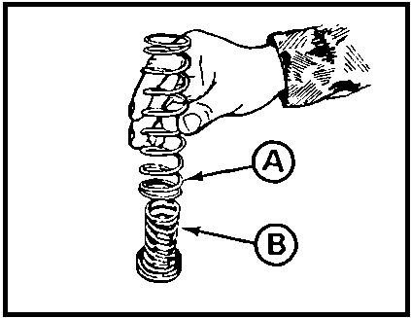

Figure 44. Removing springs.

(5) Remove the sear pin (Figure 45).

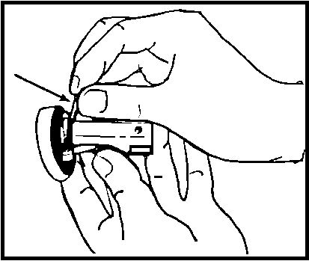

Figure 45. Removing seat pin.

(6) Remove the sear (Figure 46 A ), firing hammer spring B ,
firing hammer C , and cup D from the hammer guide yoke E .

(7) Remove the firing hammer spring B from the sear A .

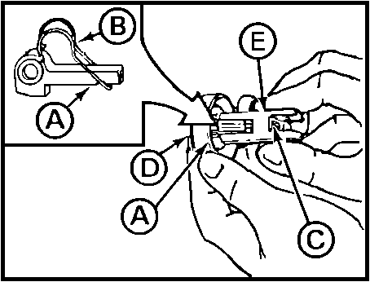

Figure 46. Removing the sear, hammer, and cup.

(8) Remove the follower (Figure 47 A ) from the case B .

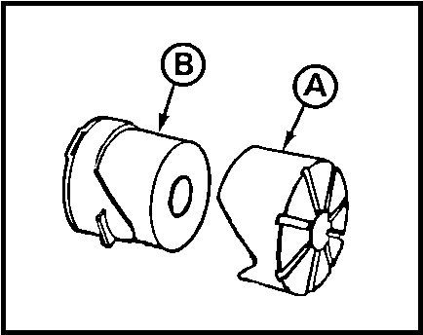

Figure 47. Removing follower.

(9) Clean all parts of the firing mechanism assembly (Figure 48) with
cleaning compound (TM 9-1025-211-10), and wipe dry. Apply a light coat of PL-S
(TM 9-1025-211-10).

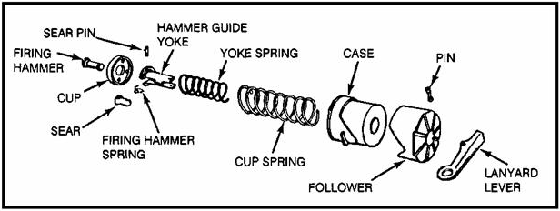

Figure 48. Firing mechanism assembly parts.

(10) Replace any worn or broken authorized parts.

d. Reassembling firing mechanism assembly.

(1) Place the follower (Figure 49 A ) over the case B .

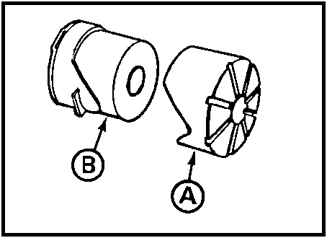

Figure 49. Placing follower over case.

(2)Place the firing hammer spring (Figure 50 A ) on the sear
B .

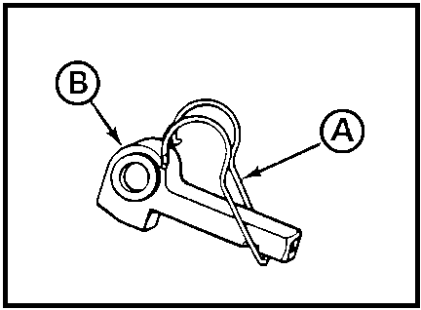

Figure 50. Replacing firing hammer spring.

(3) Place the cup (Figure 51 A ) on the firing hammer B .

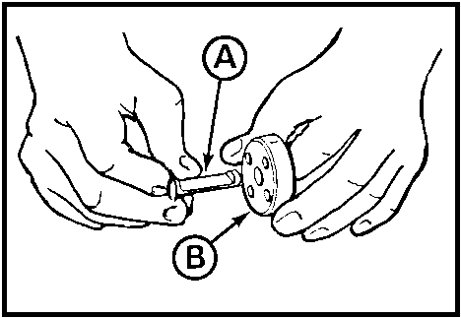

Figure 51. Placing cup on firing hammer.

(4) Place the hammer guide yoke (Figure 52 A ) on the firing
hammer B .

(5) Place the sear C , with the firing hammer spring D
attached, into the hammer guide yoke A .

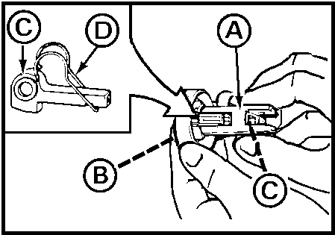

Figure 52. Hammer guide yoke.

(6) Secure the sear (Figure 53 A ) with the sear pin B .

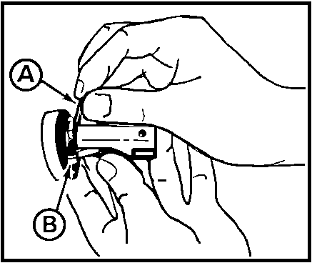

Figure 53. Securing sear.

(7) Place the yoke spring (Figure 54 A ) on the hammer guide
yoke B .

(8) Place the cup spring C over the yoke spring A .

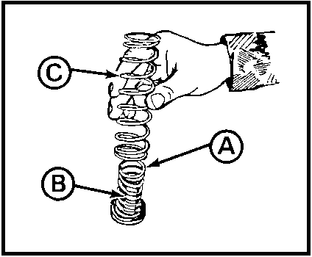

Figure 54. Reassembling springs.

(9) Place the case (Figure 55 A ), with follower B , over
the assembled guide yoke C , and place on a solid surface.

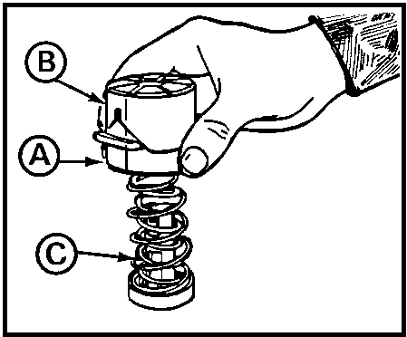

Figure 55. Placing case on hammer guide yoke.

(10) Place the M18 fuze-setter wrench (Figure 56 A ) over
the case B and follower C . Depress the case and follower until
the pin hole in the hammer guide yoke D is exposed.

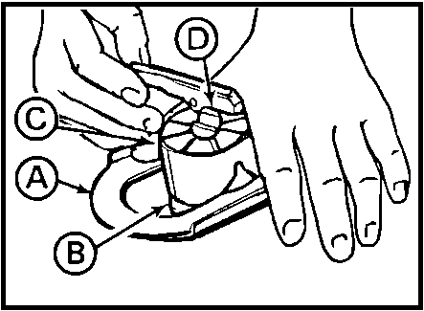

Figure 56. Depressing the case and follower.

(11) Place the lanyard lever (Figure 57 A ) over the assembled
hammer guide yoke B , and install the pin C .

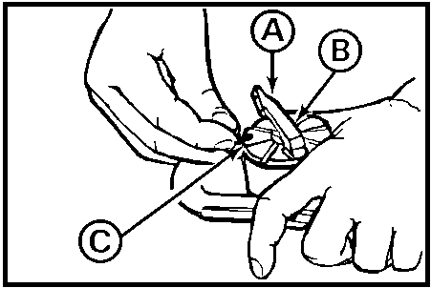

Figure 57. Installing pin.

8. MONITORING BRAKE ASSEMBLY.

a. Connect hose assemblies to prime mover. Check length of travel of
power booster indicator rod (Figure 58) while prime mover brakes are applied.
If indicator rod moves more than 1-3/4 inches (4.45 cm), notify organizational
maintenance.

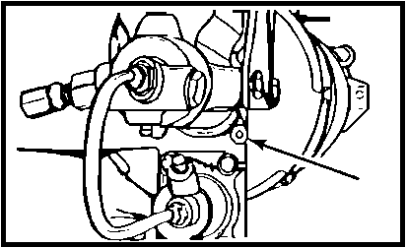

Figure 58. Power booster indicator rod.

b. Disconnect hose assemblies (Figure 59) from prime mover. This should
set the brakes automatically on howitzer. Move howitzer slightly with prime
mover to ensure brakes are set.

WARNING

CLOSE PRIME MOVER CUTOUT COCK TO PREVENT INJURY FROM AIR PRESSURE.

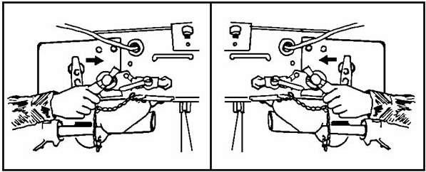

Figure 59. Hose assemblies.

9. VERIFYING RECOIL MECHANISM. For you the platoon leader to verify the recoil mechanism, you will need to check the oil level.

CAUTION

THE OIL LEVEL IS ADEQUATE WHEN 2 THROUGH 10 RESERVES ARE REGISTERED ON THE OIL
RESERVE INDICATOR (FIGURE 60). AFTER A DAY'S FIRING, EXCESS OIL REMOVED MUST BE
RETURNED (USE NEW OIL, BECAUSE MECHANISM MAY HAVE MINUS RESERVES AND AIR WOULD
BE INTRODUCED INTO THE SYSTEM). FILL RECOIL MECHANISM TO 3 OIL RESERVES.

NOTE: More than 10 reserves will cause the weapon to slam into battery during
firing.

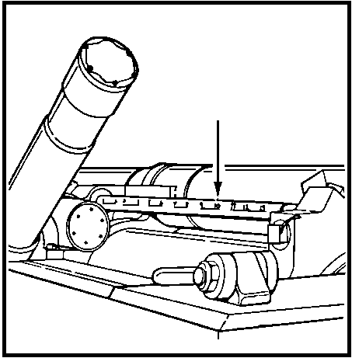

Figure 60. Oil reserve indicator.

10. MONITORING BREECH MECHANISM AND COUNTERBALANCE.

a. Check breechblock assembly (Figure 61 A ) and breech counterbalance
B by opening and closing breechblock assembly. Check for smooth operation and
alignment of witness marks C .

NOTE: Equipment is not ready/available if the breechblock assembly will not
close or the witness marks do not align.

b. Check for loose bolts and missing or damaged parts, especially the
torque key D and tube lock key E . If bolts are loose or missing or parts are damaged, notify organizational maintenance.

NOTE: Equipment is not ready/available if the torque key or tube lock key is
missing.

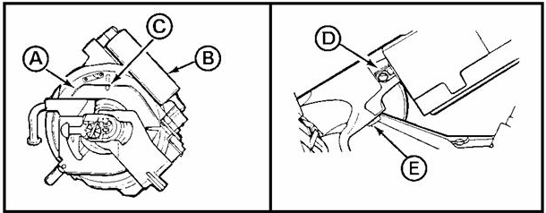

Figure 61. Breech mechanism assembly.

11. MONITORING AND/OR ADJUSTING EQUILIBRATOR CYLINDERS. (See Figure 62.)

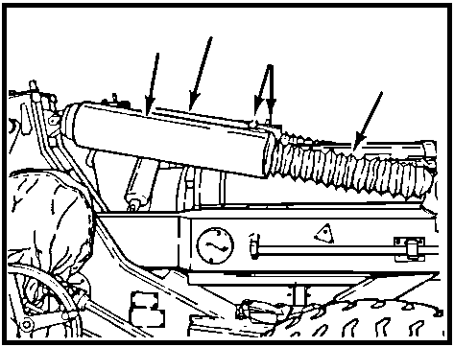

Figure 62. Equilibrator cylinders.

WARNING

MAKE SURE PERSONNEL ARE CLEAR OF CANNON RECOIL PATH. LOSS OF NITROGEN PRESSURE
CAN ALLOW CANNON TO FALL OUT OF BATTERY.

a. Elevate and depress the weapon. It should take the same effort to
elevate and depress the weapon. If not, adjust the equilibrator.

b. If the cannon does not remain in battery when the weapon is elevated,
stop elevating and return to travel lock.

12. VERIFYING ADJUSTMENTS ON M17 AND M18 FIRE CONTROL QUADRANTS. To verify
adjustments on the M17 or M18 fire control quadrants, you will perform the
following steps:

- Perform an end-for-end test on the gunner's quadrant to find out if it is serviceable and what corrections, if any, are there.

- Set the announced quadrant plus any corrections on the gunner's quadrant.

- Place gunner's quadrant on the quadrant seats of the M17 or M18 fire control quadrant.

- Elevate or depress the tube until the bubble centers on the gunner's quadrant.

- Set the announced quadrant on the M17 or M18 fire control quadrant. The bubble should center. If the bubble does not center, turn the M17 or M18 fire control quadrant into organizational maintenance for repairs.

13. SUMMARY. In this lesson, you have been shown procedures for verifying and
monitoring critical maintenance tasks that you may be required to do. If you
feel you are ready to take the final examination, continue to the next page. If
not, review Lessons 1 and 2.

